Jennifer Stegina

3 September 2019

CIS 250

**Unit 2 Guided Practice 2**

The following questions come from the Task examples of each section of Chapter 4 in your textbook.

After you are finished, please submit the Microsoft Word file that contains screenshots of the SQL queries and the output. Place a comment line in your query containing your name. Your document should be named **U2_GuidedPractice2_Lastname.docx**.

(4-1) Question 1:

Save the result table of the following *select* statement. Create a new permanent table. Show how to change a select statement so that the result is saved in a new table, instead of being displayed on the screen. Name the new table *sec0401_sales_staff*.

select *employee_id,*

*first_name,*

*last_name,*

*dept_code*

from *1_employees*

where *dept_code* = 'SAL'

order by *employee_id*;

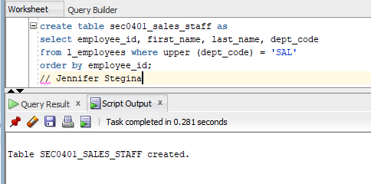

(4-2) Question 2:

Save the result table of the following select statement. Here we are getting a few rows and a few columns from a table. Create a new view from this select statement and name it *sec0402_sales_staff_view*.

select *employee_id,*

*first_name,*

*last_name,*

*dept_code*

from *1_employees*

where *dept_code* = 'SAL'

order by *employee_id*;

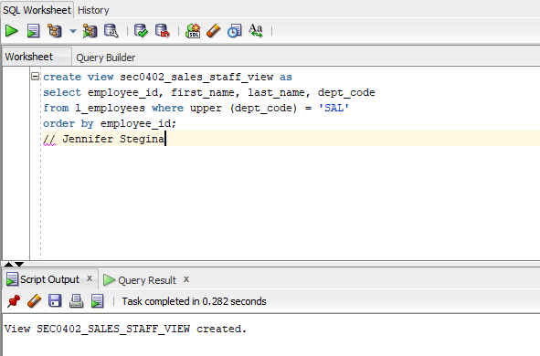

(4-5) Question 3:

Delete the table named *sec0405_sales_staff*.

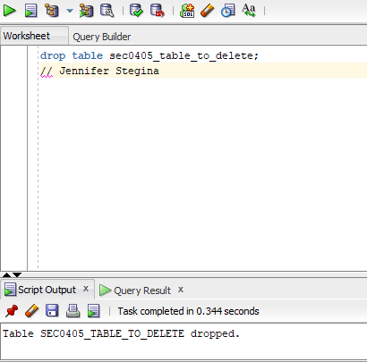

(4-7) Question 4:

Create a view, named *sec0407_sales_staff_view1*, that lists the employees in the sales department. Show the following columns: *employee_id*, *first_name*, *last_name*, and *dept_code*.

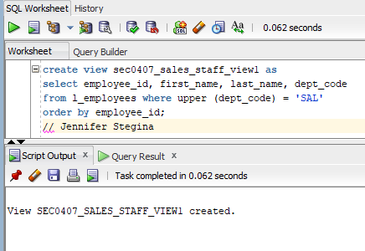

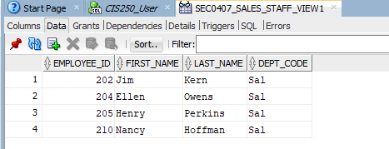

Then create another view, named *sec0407_sales_staff_view2*, from the first view. Use all the rows from the *sec0407_sales_staff_view1*, except the ones with *employee_id* greater than 208. Use all the columns from the *sec0407_sales_staff_view1* except *dept_code*.

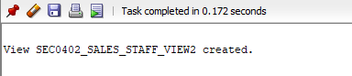

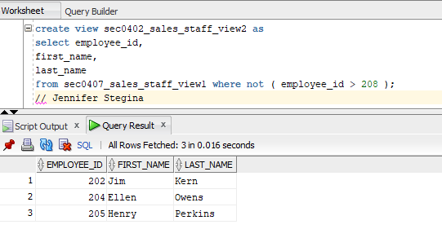

(4-9) Question 5:

Add two new rows to the *sec0409_foods* table. Show the two methods of adding a single row.

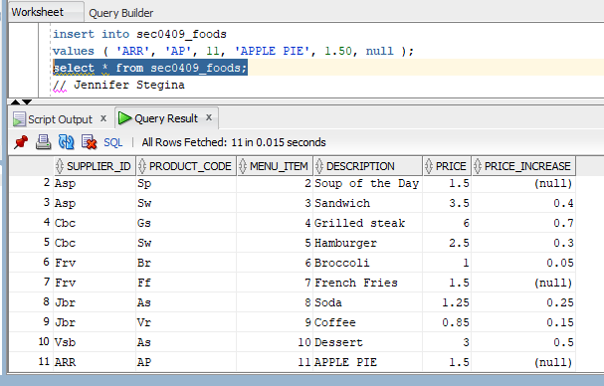

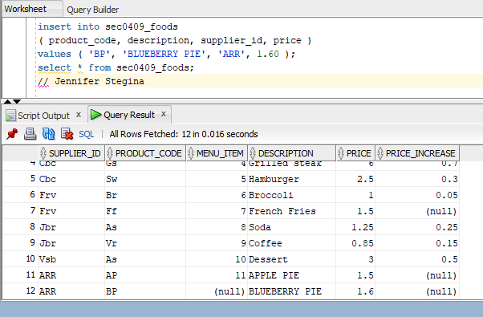

(4-10) Question 6:

In the *sec0410_foods* table, duplicate all the rows from supplier ASP and change the supplier to ARR. Put nulls in the price and *price_increase* columns of the new rows.

You might do this if you are unhappy with supplier ASP and you are now going to get all those products from supplier ARR. This task would be the first step. The next step would be to delete all the rows for supplier ASP.

So that you can run both versions of this code, method 1 and method 2 use two different copies of the *l_foods* table.

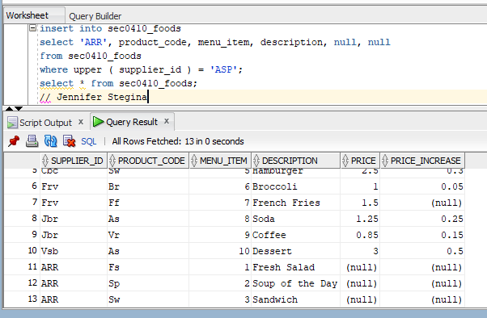

(4-12) Question 7:

Delete all the rows with *supplier_id* values of cbc and jbr from the *sec0412_foods* table.

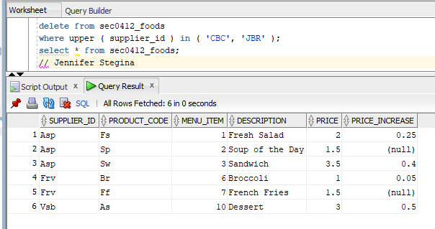

After you are finished, please submit the Microsoft Word file that contains screenshots of the SQL queries and the output, and include a comment containing your name. Your document should be named **U2_GuidedPractice2_Lastname.docx**.